**JESD Trucking Website**

**Fall 2018**

**Final Report**

Table of Contents

List of Project Participants 2

Abstract of the Project 3

Project Narrative 4

Design Considerations 5

Design and Specification 8

Testing and Iterative Design 9

Restrictions, Limitations, Constraints 10

Conclusion 11

List of Project Participants

**Participant**:

Eunice Montenegro

**Role**:

As the only member in this project, the role was to complete a project planning phase were the project ideas and time could have been mapped, the design portion of the project which consisted of sketching storyboards, wireframes, and coming up with design ideas to have an interface the user can feel comfortable looking and interacting with the website.

Abstract of the Project

The project that was done for Comp 336– Markup Languages as a website for JESD Trucking that would help them establish a web presence. As of now, JESD Trucking is a small family business that transports loads in the Midwest. To further the business and truly have it expand in a digital era, creating an informative website is the best way to help JESD Trucking’s customers learn about the company and trust their services.

Project Narrative

The goal for this project is to create a web presence for JESD Trucking using a variety of mark-up languages to create a website that is enjoyable for the user. This project holds many aspirations because they do not have a website so the possibilities are endless. Some aspirations are to have a website that is not only informative for the random user who is intrigued to learn about JESD Trucking but also for the users who already have an established relationship with the company such as business partners. For the business partners the website would serve as an informative site that will inform them of the mission, promises and about specific loads that are relevant to them through a login which would prompt them to enter an interface specific to their company.

As of now (December 10, 2018), JESD has a website that is informative for all users. The information ranges from logistics on the commodities they transport to information about the team at JESD Trucking. The reason for building this is to have the users learn more about the company without the need to call the company.

Design Considerations

**Original Project Concepts**:   
The initial concept for the project was an informative website that could help end users learn more about JESD Trucking.

**Datasets**:

* Company Team: Information on who and what roles employees hold at the company.
* Contact information: Location of JESD; Phone Number; Email
* Commodities Moved: Materials that JESD Trucking moves into and out of Midwest states for their partners.

**Inspiration**:

By looking at different transportation companies it was easier to grab inspiration on design and structure. The following websites were used:

J.B. Hunt Transport Services: <https://www.jbhunt.com/>

C.H. Robinson Worldwide: <https://www.chrobinson.com/en-us/>  
Total Quality Logistics: <https://www.tql.com>

Coyote Logistics: <https://www.coyote.com/>

**Encoded Documents:**

The primary goal of the encoded documents was to inform the reader about JESD Trucking. The markup language chosen was HTML because it is universally used, and considered to be the most common language used for making websites. HTML allowed for the information of the company to be displayed in an organized matter with sections and divisions.

**Consistency:**

To ensure consistency with the page structure I made sure to include the same background color, header, and footer for each page. The header was on the top of the page which consisted of a navigation bar. The footer had a copyright line on the bottom of the page. The schema used and development helped when deciding the path someone was going to take while on the website. It also helped to keep an organized implementation stage as each page had a purpose and information that was unique to it. The metadata used for the project was the metadata tag <meta charset="UTF-8"> which stand for Universal Character Set and Transformation Format—8-bit. The decision to use this meta tag came when research was done. According to online sources it is used for 93% of website traffic. This tag specifies which character set the website is written in. By using HTML the websites semantics were easily discovered. For example, the header had a <nav> tag that stands for navigation, or <li> tag that stands for the list tag. The main content on the website includes other tags such as <h2>, <h6>, <p>, and <div> which help identify what the content is for example tag p would be for paragraphs in the website.

**Feedback from DEV week:**

Based on the feedback received from DEV week, some alterations to the final project were made. On the navigation bar the underline on the homepage was removed as the underline was positioned right on the line of the navigation bar and the main content. In addition, the sub titles on the website’s homepage such as “About JESD Trucking” was changed to remove the underline as it already had the text bold. Other changes where to add 3 new pages for each member of the organization as the home page was getting long compared to the other pages on the website. These changes impacted the website by not including redundancy, and having a consistent website.

**Architecture**:

For the architecture of the project, it was decided to have each page be a separate file and have a folder specifically for the CSS which is the style sheet language used in this project. JavaScript was also used for the interaction between the user and the website. It also had its own folder. In addition, Bootstrap was used to enhance the visual display of the website as it already had code that was useful for the project.

Design and Specification

**Mockup:**

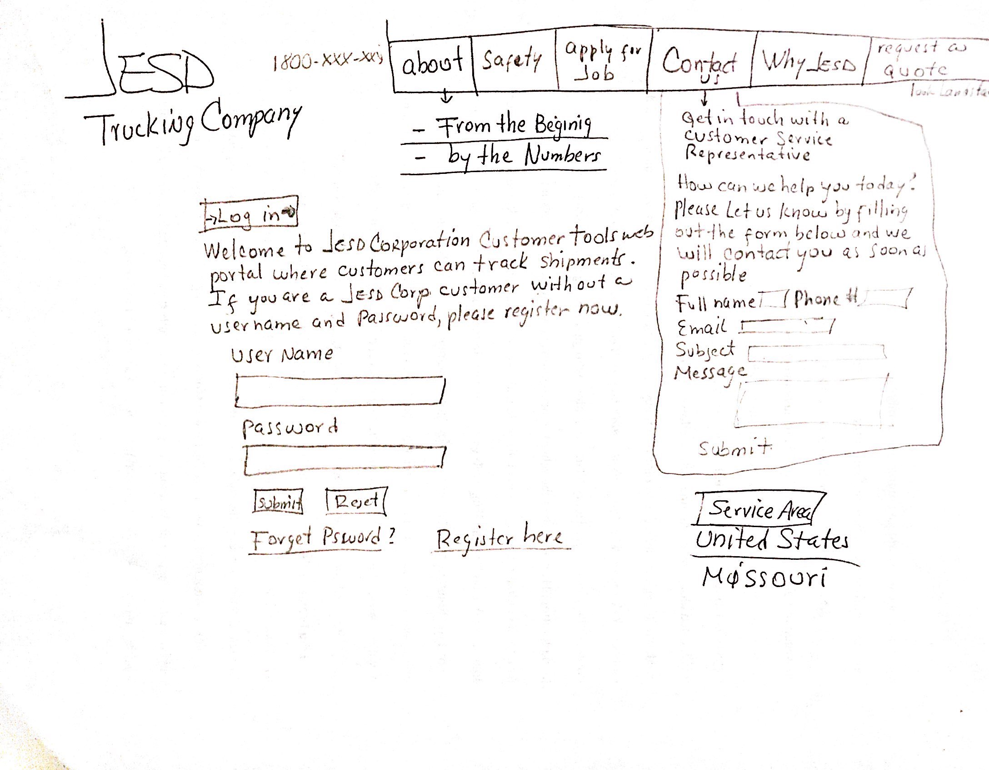 **Design Development:**

Based on the initial concept the finished application did change. The initial concept included a webpage for JESD Trucking Partners to log in and access a portal with information on their load such as the status of the load being: delivered, picked up, or on its way. Also, there would be a link seen in the mockup where people could potentially apply to work for JESD Trucking. Although these things did not end up on the final product, other things did such as a section for about the company were clients and any user can read more about the company and its history. The contact information was also added as a tab on the navigation bar for anyone to contact the company. In addition, a section for guaranty/promise to the customer was added because the owner of JESD Trucking believed it was important to display our relationship with our users and what we aspire.

Testing and Iterative Design

When it came to testing, it was important to have every link working and every image display as it would be something that would disturb users if the website included a section they wanted to learn more about but they could not click on it as the link wouldn’t work. To test this, the website was tested on different browsers such as Chrome, Firefox and Safari. Feedback was also a great component of testing as the website was presented to different users and the team at JESD to get their option on the website.

Restrictions, Limitations, and Constraints

Unfortunately, there were some limitations with the project such as not having enough content. There were sections such as *Why Us* that were important to JESD Trucking as it allowed the users to read about why they should partner with JESD Trucking. However, it was hard at times coming up with enough content to fill the page. Other limitations were the limited knowledge of database usage. As the initial concept included a part for users to log in, the website had to be connected to a database. Although this was a limitation, it was okay as it was not a requirement for this class. A constraint was using bootstrap, although bootstrap has amazing templates and functions it also got complicated when using the tool as it was very abstract and included many functions that I might not need or want. So, most of my time would be spent decoding searching for what I need.

Conclusion

Reflecting on the project, I believe that it achieved its goal of creating a web presence for JESD Trucking. It allows the viewer to learn more about the business and the team. It also allows for those people who are interesting in becoming partners to know the companies promise of care, fast, and success. Through tools and technologies used, the website was able to display informative content in an organized way with design implemented through the use of bootstrap and CSS. For the future, the JESD Trucking website has much room for improvement such as adding a database connection to store interactions and partners. As well as adding a review section to have partners view the option from other partners.